# Informações do estudo

Referência: Lin

Grandeza: Rugosidade

Tipo: Rugosidade a

Material: S55C high carbon steel

Ferramenta: TNMG160404L2G

Número de experimentos: 27

Observações:  
Tool holder: MTJNL2525M16  
Diameter: 64.5 mm  
Length: 250 mm

# Unidades

Velocidade: m/min

Avanço: mm/rev

Profundidade de corte: mm

Rugosidade: μm

# Dados de teste

|  |  |  |  |
| --- | --- | --- | --- |
| Rugosidade | n | f | a |
| 0.76 | 121.58 | 0.08 | 0.35 |
| 8.5 | 121.58 | 0.32 | 0.8 |
| 3.34 | 121.58 | 0.2 | 0.35 |
| 3.79 | 121.58 | 0.2 | 1.25 |
| 0.86 | 86.12 | 0.08 | 0.8 |
| 3.11 | 202.63 | 0.2 | 1.25 |

# Dados de treino

|  |  |  |  |
| --- | --- | --- | --- |
| Rugosidade | n | f | a |
| 8.28 | 202.63 | 0.32 | 1.25 |
| 3.25 | 86.12 | 0.2 | 0.8 |
| 7.56 | 86.12 | 0.32 | 0.35 |
| 7.57 | 202.63 | 0.32 | 0.8 |
| 3.63 | 121.58 | 0.2 | 0.8 |
| 0.73 | 86.12 | 0.08 | 1.25 |
| 3.06 | 86.12 | 0.2 | 0.35 |
| 9.49 | 121.58 | 0.32 | 1.25 |
| 9.03 | 86.12 | 0.32 | 1.25 |
| 1.09 | 202.63 | 0.08 | 0.35 |
| 0.9 | 86.12 | 0.08 | 0.35 |
| 0.85 | 202.63 | 0.08 | 1.25 |
| 7.0 | 202.63 | 0.32 | 0.35 |
| 2.81 | 202.63 | 0.2 | 0.35 |
| 1.06 | 202.63 | 0.08 | 0.8 |
| 8.12 | 86.12 | 0.32 | 0.8 |
| 0.84 | 121.58 | 0.08 | 0.8 |
| 0.71 | 121.58 | 0.08 | 1.25 |
| 7.94 | 121.58 | 0.32 | 0.35 |
| 3.47 | 86.12 | 0.2 | 1.25 |
| 3.15 | 202.63 | 0.2 | 0.8 |

# RN

Número de neurônios: 83

Taxa de aprendizado: 1.000000e-02

Número de épocas: 337

2° camada: True

Função de ativação: relu

# Erros

**Dados de teste**

* Erro relativo médio: 16.61
* Coeficiente de correlação: 0.99
* Coeficiente de determinação: 0.98
* MSE: 0.12
* RMSE: 0.35

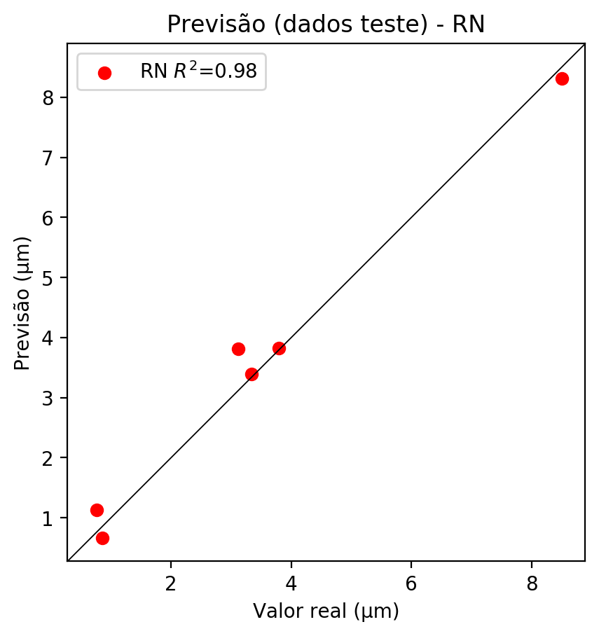

**Dados de treino**

* Erro relativo médio: 0.15
* Coeficiente de correlação: 1.0
* Coeficiente de determinação: 1.0
* MSE: 0.0
* RMSE: 0.0

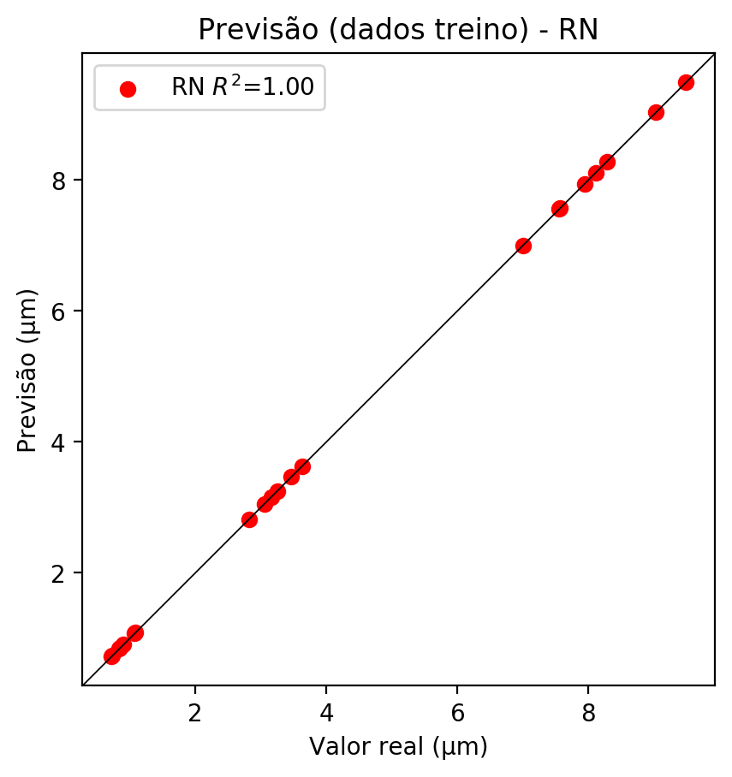

# Pesos

Pesos - camada oculta 1

[[ 0.08942637 -0.00852813 -0.11650497 0.01538777 0.23161776 -0.10287753  
 -0.03445515 0.11636568 -0.09692505 0.22154172 -0.25908878 0.20851162  
 0.04664068 -0.0665381 -0.14934494 -0.03935239 0.15958269 0.06655475  
 -0.24410178 0.07831529 0.19897456 0.23967837 0.07413179 0.05035423  
 -0.11300489 -0.22109453 0.2071738 -0.00570196 0.14174828 -0.06546798  
 0.02130607 -0.15208845 -0.17539035 -0.13947566 0.1074361 -0.10903627  
 0.03055139 0.15370823 -0.2713268 0.00765243 0.13977836 -0.0070615  
 0.28414932 0.18028177 0.0535536 0.07654369 0.07842021 -0.0450261  
 0.15030214 0.29592443 0.24765389 0.11429261 -0.02567578 0.06056523  
 -0.11039238 -0.05808228 -0.0566289 0.06254896 -0.2372186 -0.14811516  
 0.2588606 -0.05314654 -0.15802853 0.13129625 0.18371475 -0.2075761  
 0.0538188 0.07454544 -0.25513878 -0.14247994 -0.02351295 0.09389035  
 0.08260218 -0.1384745 0.02956873 -0.21240725 0.12889042 0.11426466  
 0.11998451 -0.06372983 0.04194832 -0.32148993 -0.20960239]  
 [ 0.01077112 -0.05895182 0.26527238 -0.03938184 -0.2322256 -0.21828678  
 0.19169287 -0.13084312 -0.22678967 -0.27126673 0.12790498 -0.04925546  
 -0.13003016 -0.19345686 0.11630604 0.01858796 -0.18474635 0.14524418  
 -0.1621741 0.14342406 -0.17404312 -0.25741896 -0.19914053 -0.06414255  
 -0.06867071 0.09334866 0.0901134 -0.00671945 -0.05998353 0.28720203  
 0.1367826 0.09935389 0.17067355 -0.05257812 -0.15026136 -0.09617098  
 -0.08569539 -0.00844711 -0.1819488 0.06757973 -0.11770039 0.20101053  
 0.05610241 0.2590714 0.00642086 -0.2177077 -0.00516821 0.17717019  
 -0.00041197 -0.00539885 0.01567064 0.2783278 0.10431236 -0.0849802  
 0.00579431 -0.1155667 0.19192962 -0.03990392 -0.23599191 0.03171723  
 -0.04169961 -0.00746379 -0.12600318 0.15712737 0.05123542 0.26220632  
 0.13454643 0.25938818 -0.22357295 -0.07360433 -0.20125747 -0.09179742  
 -0.2832001 0.16368552 0.15279174 0.1632917 0.03704814 -0.11132843  
 0.20054981 -0.20379756 -0.04124209 -0.22376598 -0.1460476 ]  
 [ 0.26272458 -0.19199026 -0.1366539 -0.03569518 -0.04315587 0.15145503  
 -0.1750743 0.07558688 -0.20332257 0.17215951 -0.22030221 0.20758305  
 0.15644799 -0.26162088 0.3080935 0.10298312 0.10363493 0.00583975  
 -0.02744714 -0.17639129 0.0869294 0.24690114 -0.11528116 -0.12244958  
 0.02370798 -0.10696448 -0.01228382 0.01063651 0.01131391 -0.01895672  
 0.0873526 0.06166851 -0.1908417 0.02755262 0.06179158 -0.24882348  
 0.2460097 0.02251665 -0.09155352 -0.04932195 -0.10501899 -0.03529261  
 0.05937847 0.22620705 0.04935265 -0.18997894 -0.17481074 0.12922558  
 0.10496762 0.17307806 0.14405717 0.17329282 0.17639782 0.17687932  
 0.06540698 0.17845502 -0.0304585 0.10760627 0.14675081 -0.11248197  
 0.015551 -0.03731667 0.02656332 -0.28255802 -0.27842447 -0.06249486  
 -0.00065067 -0.24508287 0.13009746 0.03025169 -0.14824909 -0.14039205  
 0.24185428 -0.09431342 0.08672274 0.02513302 0.16058043 0.06032829  
 0.1644049 0.21573485 0.12206379 -0.03702353 -0.01671859]]

Bias - camada oculta

[-0.02412956 -0.06758884 0.02960883 -0.09497446 0.00699415 -0.0315522  
 -0.04917997 -0.08165527 0.03077912 0.05920389 0.04240441 0.05744246  
 0.00628701 -0.03842924 0.02945125 -0.09237365 -0.00938659 -0.01900822  
 0.0522871 -0.11147156 -0.05113933 0.07903425 0.05302065 0.00659343  
 -0.0579841 0.03562149 -0.10360334 -0.0956016 -0.08894791 0.01456403  
 -0.08983064 -0.10038 -0.09241135 -0.04677787 -0.04701069 0.06837302  
 -0.07508583 -0.07521997 0.02968511 -0.05379559 0.01888429 -0.06852553  
 0.03161333 -0.0040175 -0.0703723 0.05896349 -0.11308843 -0.0468457  
 -0.05227699 0.05756813 0.02901096 0.02874548 -0.06786218 -0.028529  
 -0.10146389 -0.0650481 -0.02913782 -0.1240821 0.04369719 -0.09408019  
 0.10981987 -0.16224593 -0.01845559 -0.04231432 -0.08959038 0.03141542  
 -0.03444098 -0.00856754 0.05073277 0.0904014 0.06496328 -0.04567348  
 0.04456865 -0.0384229 -0.0772817 0.05417155 0.03849643 -0.0656893  
 -0.00158646 0.01677987 -0.12332816 0.1201409 -0.00933476]

Pesos - camada oculta 2

[[ 0.11925663 -0.00311132 -0.2320674 ... 0.05874334 -0.12139373  
 -0.28473756]  
 [-0.14447257 -0.17426486 0.17736436 ... -0.05758654 -0.10860635  
 -0.20351698]  
 [ 0.18583113 -0.05329505 -0.23090003 ... 0.06604322 0.03619345  
 -0.04703615]  
 ...  
 [ 0.04497037 -0.021491 0.06489691 ... -0.02117132 -0.03040054  
 0.07475042]  
 [-0.14654085 -0.16328204 0.10626043 ... 0.00417057 0.2162824  
 -0.02545885]  
 [ 0.12312131 -0.09367752 -0.01558274 ... 0.01580201 0.17873557  
 -0.11611389]]

Bias - camada oculta 2

[ 4.09975611e-02 7.40508549e-03 -9.26549807e-02 1.38043119e-02  
 -1.12062677e-04 -8.70024562e-02 -1.15367258e-03 1.46301799e-02  
 -1.17863752e-01 1.55304270e-02 -3.26115936e-02 4.73560281e-02  
 1.76694710e-02 -6.06788807e-02 -7.49158934e-02 -7.53773898e-02  
 2.23642029e-02 -1.05983019e-01 6.47794157e-02 -8.97187069e-02  
 -6.58966452e-02 1.44022414e-02 2.64502056e-02 1.84616279e-02  
 8.24055541e-03 8.62399936e-02 -5.67314811e-02 -9.72072184e-02  
 3.89842056e-02 -1.23250104e-01 7.14447675e-03 4.98254672e-02  
 2.54127569e-02 -7.26609752e-02 1.69654265e-02 6.46045431e-02  
 2.50853561e-02 1.15938382e-02 5.58369830e-02 3.46962083e-03  
 6.48486195e-03 3.44257317e-02 4.66696993e-02 -7.37730116e-02  
 9.38054267e-03 -2.06180122e-02 -8.52956027e-02 -3.19769718e-02  
 4.12993804e-02 -7.39213452e-02 -3.36896293e-02 -6.16561547e-02  
 -1.17036719e-02 2.54812441e-03 -4.99093793e-02 -5.45115396e-03  
 7.07998453e-03 9.65180621e-02 -6.00528605e-02 -8.27789009e-02  
 3.48149166e-02 -1.20111950e-01 6.19310737e-02 -6.00484237e-02  
 4.78200801e-02 -1.30462810e-01 -4.29761596e-02 1.19813103e-02  
 7.72040337e-02 -8.53661299e-02 8.39693993e-02 -6.46057501e-02  
 -8.00089985e-02 0.00000000e+00 5.42678423e-02 -9.66902003e-02  
 3.04124039e-02 -2.72790100e-02 2.23304122e-03 -8.07654560e-02  
 -2.83748955e-02 8.41169655e-02 -8.77113268e-02]

Pesos - camada saída

[[ 2.02573478e-01 8.40672478e-02 -6.68031052e-02 6.70582801e-02  
 1.06767170e-01 -2.60462090e-02 1.23866731e-02 2.44562589e-02  
 4.64431709e-03 9.64950770e-02 -2.55968004e-01 1.39907330e-01  
 1.02423854e-01 2.62278616e-02 -5.10921404e-02 -3.48829925e-02  
 2.34096386e-02 1.01642804e-02 -1.87322572e-01 1.41218722e-01  
 1.67052403e-01 2.05404386e-01 -4.31970395e-02 1.50166482e-01  
 -2.01532207e-02 -1.83961004e-01 1.69891417e-01 -6.88608643e-03  
 1.58458918e-01 -9.76053476e-02 -2.35450808e-02 -2.19957873e-01  
 -1.68998972e-01 -1.01583935e-01 5.39762229e-02 -1.96988806e-01  
 8.15753043e-02 1.25985533e-01 -1.41678795e-01 -6.22386113e-02  
 1.09675176e-01 9.59865674e-02 1.57023504e-01 1.60028502e-01  
 1.40849352e-01 -2.38899998e-02 1.71411205e-02 -5.05651012e-02  
 2.51268536e-01 1.98673368e-01 1.82015717e-01 7.82520697e-02  
 6.54117167e-02 -2.85291243e-02 -8.67292136e-02 4.07281891e-02  
 5.44930734e-02 -3.50755799e-05 -1.86727837e-01 -1.62944913e-01  
 2.47535154e-01 -1.19314969e-01 -1.93894267e-01 9.26720258e-03  
 2.85576731e-01 -1.19857907e-01 4.02210793e-03 1.06796183e-01  
 -2.01527253e-01 -3.70536596e-02 -7.61799961e-02 -3.57233733e-02  
 5.62442504e-02 -1.93893909e-01 1.32132590e-01 -7.60743171e-02  
 8.31474736e-02 1.48352638e-01 2.46510077e-02 -3.59239019e-02  
 1.88099205e-01 -2.68842340e-01 -1.85272843e-01]]

# Iterações

|  |  |  |  |  |  |  |
| --- | --- | --- | --- | --- | --- | --- |
| Média | Desvio | n | ln | 2° camada | Função | Épocas |
| -0.0278 | 0.0251 | 10 | 0.1 | False | relu | 38 |
| -0.0329 | 0.0465 | 17 | 0.1 | True | relu | 716 |
| -0.0582 | 0.0604 | 7 | 0.01 | True | tanh | 130 |
| -0.1245 | 0.0723 | 19 | 0.001 | False | tanh | 282 |
| -0.0875 | 0.0475 | 29 | 0.001 | False | relu | 469 |
| -0.059 | 0.0645 | 88 | 0.1 | False | tanh | 926 |
| -0.0608 | 0.0454 | 95 | 0.0001 | True | relu | 984 |
| -0.0251 | 0.0207 | 10 | 0.01 | True | tanh | 865 |
| -0.7219 | 0.2098 | 58 | 0.001 | True | relu | 8 |
| -0.0534 | 0.0487 | 9 | 0.01 | False | tanh | 514 |
| -0.0739 | 0.054 | 73 | 0.0001 | True | relu | 729 |
| -0.0901 | 0.1452 | 22 | 0.001 | True | relu | 543 |
| -0.0254 | 0.0163 | 25 | 0.1 | True | relu | 562 |
| -0.0686 | 0.0312 | 53 | 0.001 | False | relu | 498 |
| -0.0177 | 0.0101 | 83 | 0.01 | True | relu | 337 |
| -0.1458 | 0.0943 | 99 | 0.01 | False | tanh | 16 |
| -0.0474 | 0.0367 | 23 | 0.01 | False | relu | 472 |
| -0.0782 | 0.0647 | 24 | 0.001 | True | relu | 778 |
| -0.0268 | 0.0064 | 58 | 0.01 | True | tanh | 382 |
| -0.1088 | 0.1098 | 35 | 0.1 | False | tanh | 596 |

# RL

# Coeficientes

[ 0. -0.01297492 0.975991 0.11021643]

# Erros

**Dados de teste**

* Erro relativo médio: 36.02
* Coeficiente de correlação: 0.96
* Coeficiente de determinação: 0.91
* MSE: 0.62
* RMSE: 0.79

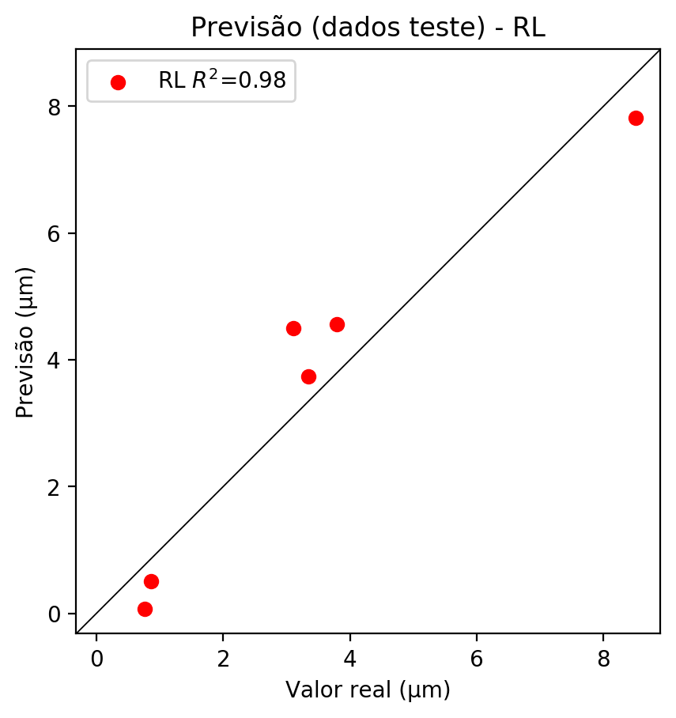

**Dados de treino**

* Erro relativo médio: 26.1
* Coeficiente de correlação: 0.98
* Coeficiente de determinação: 0.95
* MSE: 0.46
* RMSE: 0.68

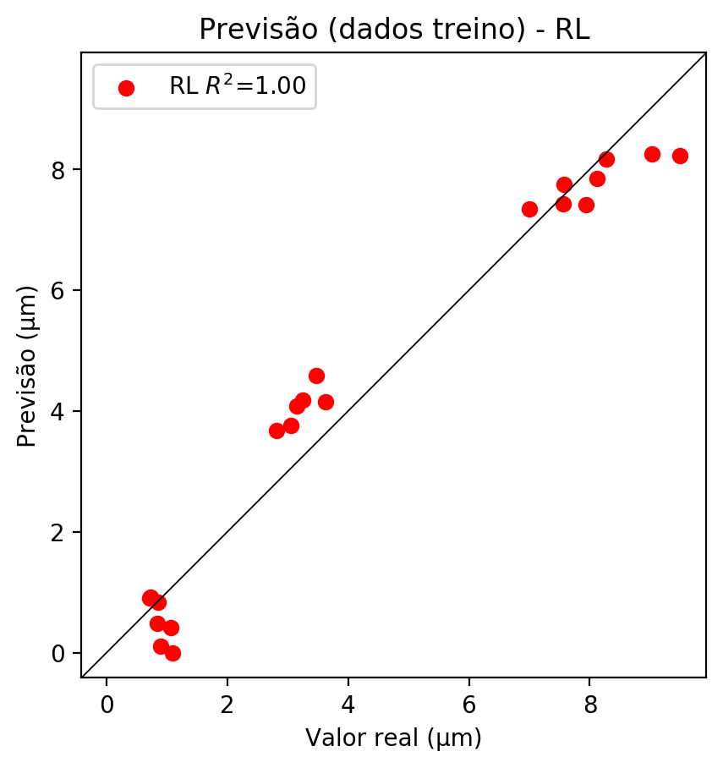

# RP2

# Coeficientes

[ 0.00000000e+00 1.08583000e-02 9.66106631e-01 7.18637154e-02  
 -1.04814549e-01 -5.65858760e-02 -1.97945795e-04 2.61371087e-01  
 9.77573670e-02 2.15127745e-02]

# Erros

**Dados de teste**

* Erro relativo médio: 20.83
* Coeficiente de correlação: 0.99
* Coeficiente de determinação: 0.99
* MSE: 0.09
* RMSE: 0.3

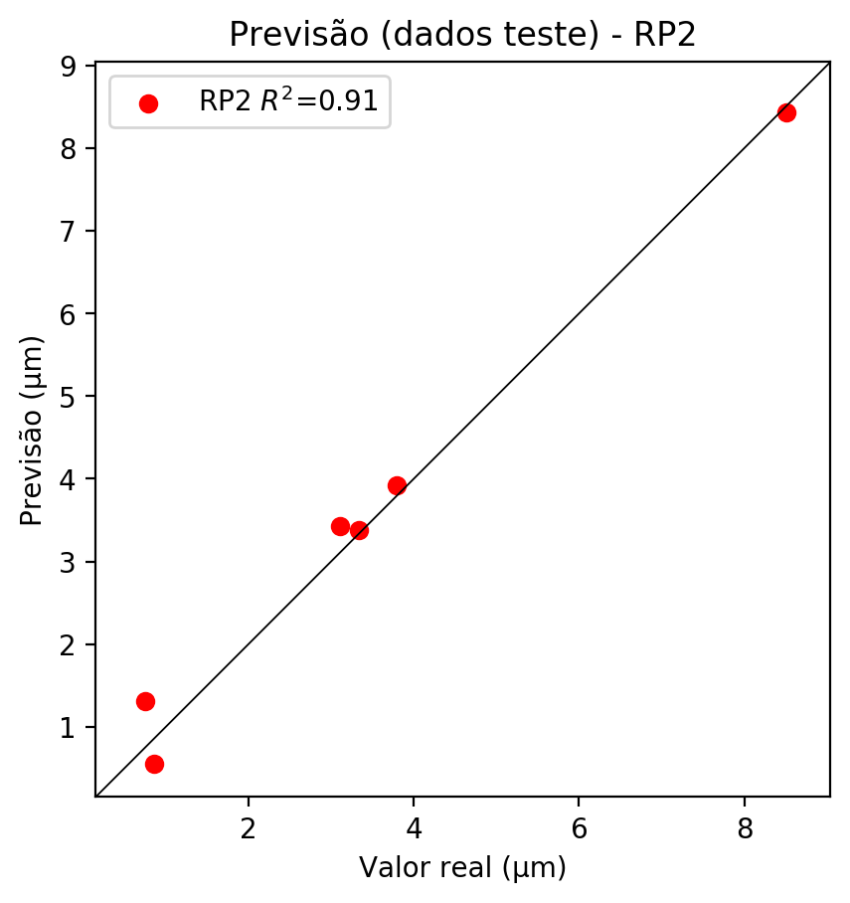

**Dados de treino**

* Erro relativo médio: 7.08
* Coeficiente de correlação: 1.0
* Coeficiente de determinação: 1.0
* MSE: 0.02
* RMSE: 0.14

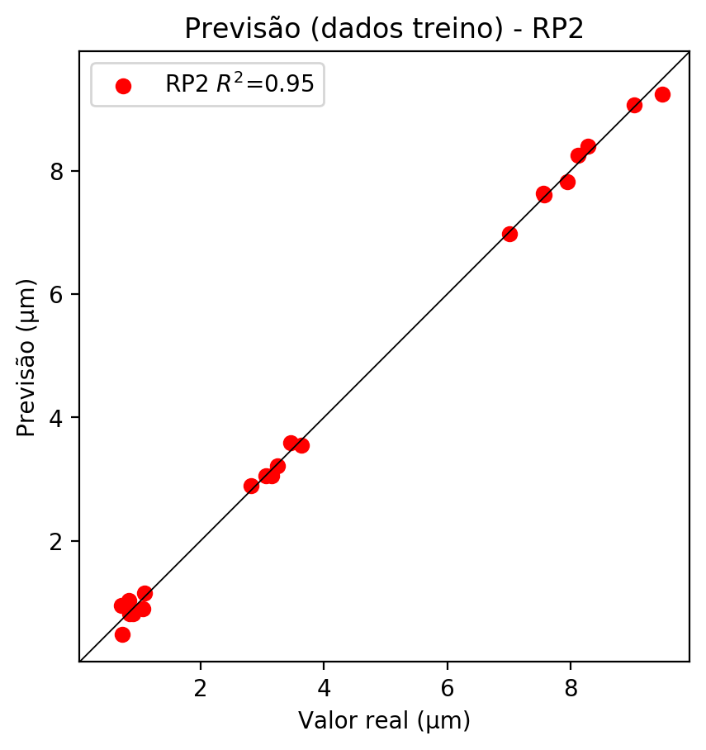

# RP3

# Coeficientes

[ 0.00000000e+00 2.38258683e-03 3.36089744e-01 2.45243235e-02  
 -8.48692445e-02 -1.91063076e-02 -2.69159053e-04 2.72037865e-01  
 8.90630614e-02 -2.22903851e-03 3.44151431e-03 -8.38372254e-02  
 -1.29806463e-02 -2.31866746e-03 -3.52640188e-03 -7.74907169e-03  
 4.85462963e-01 1.40265896e-02 1.58571710e-02 3.54240229e-02]

# Erros

**Dados de teste**

* Erro relativo médio: 3.58
* Coeficiente de correlação: 1.0
* Coeficiente de determinação: 1.0
* MSE: 0.01
* RMSE: 0.1

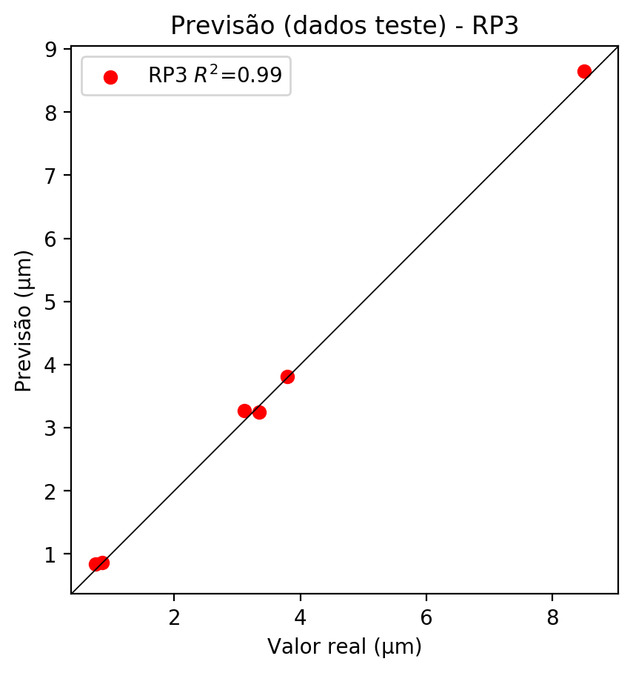

**Dados de treino**

* Erro relativo médio: 1.33
* Coeficiente de correlação: 1.0
* Coeficiente de determinação: 1.0
* MSE: 0.0
* RMSE: 0.0

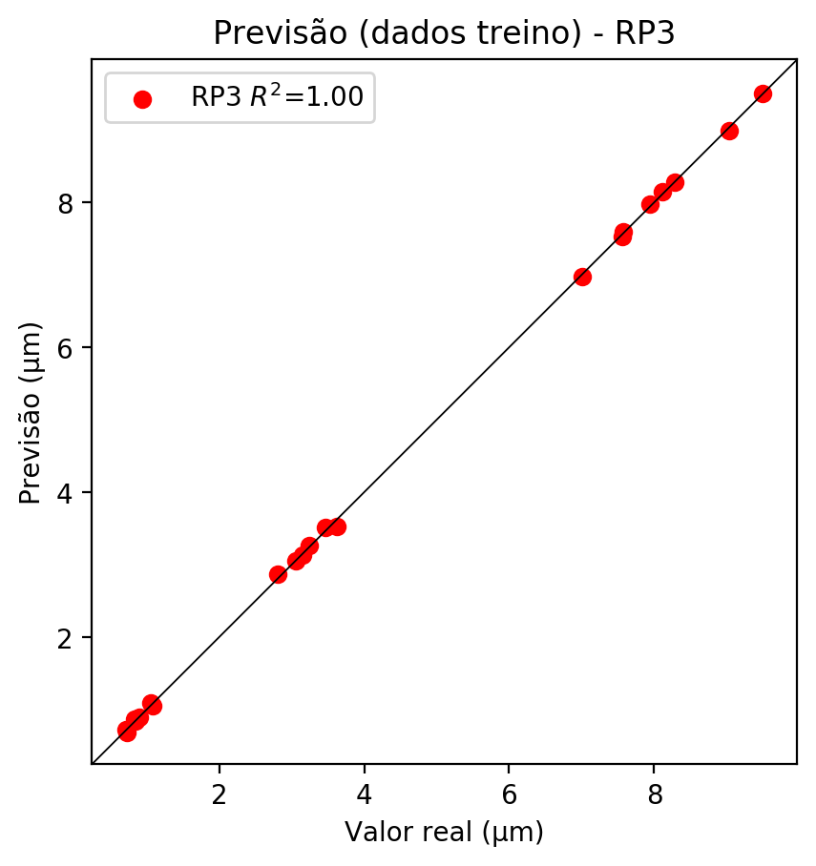

# RP4

# Coeficientes

[-2.77555756e-17 1.39130369e-02 2.99309596e-01 -5.79267688e-03  
 -3.92930821e-02 -4.34459419e-02 -2.52409937e-03 5.49794653e-02  
 3.24371846e-02 3.80803908e-02 2.00966089e-02 -1.30717768e-02  
 5.60065978e-02 -2.13210136e-02 1.48792273e-02 1.55037701e-02  
 4.32336084e-01 1.63660586e-02 1.16762734e-02 -8.36719993e-03  
 -5.10087792e-02 6.08985663e-02 -6.03905072e-03 6.59648345e-02  
 -5.90720713e-02 -9.50172906e-02 -6.27552494e-02 -5.66770273e-03  
 3.06993759e-03 -3.64592131e-03 7.94147832e-02 4.68537111e-02  
 1.80933126e-02 4.68537111e-02 5.50050089e-02]

# Erros

**Dados de teste**

* Erro relativo médio: 37.05
* Coeficiente de correlação: 0.98
* Coeficiente de determinação: 0.94
* MSE: 0.42
* RMSE: 0.65

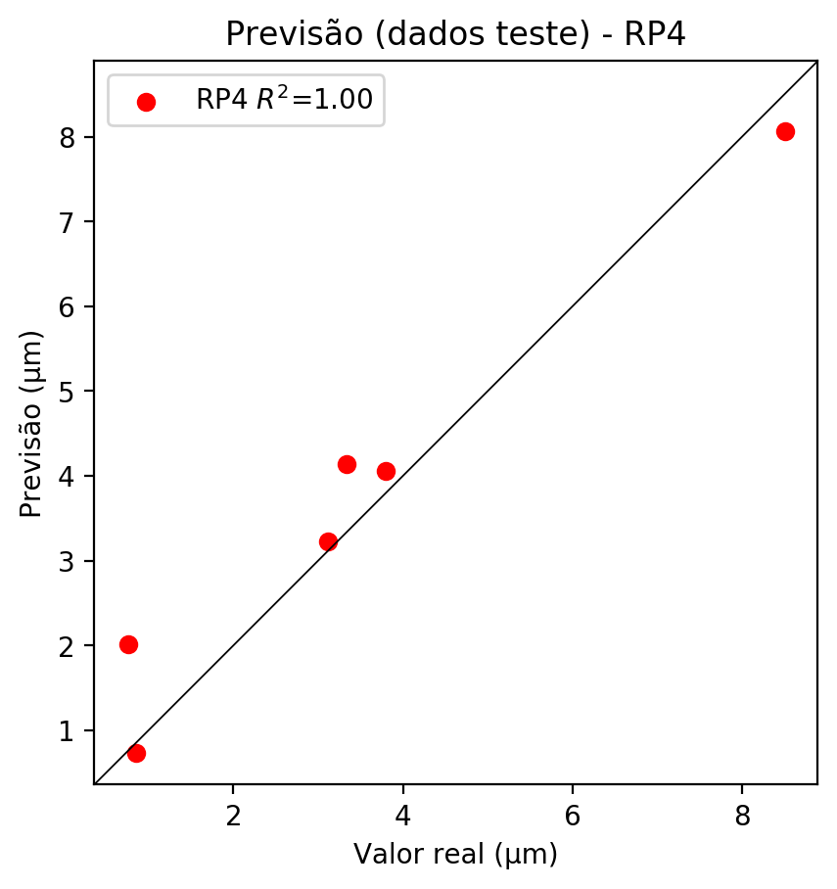

**Dados de treino**

* Erro relativo médio: 0.15
* Coeficiente de correlação: 1.0
* Coeficiente de determinação: 1.0
* MSE: 0.0
* RMSE: 0.0

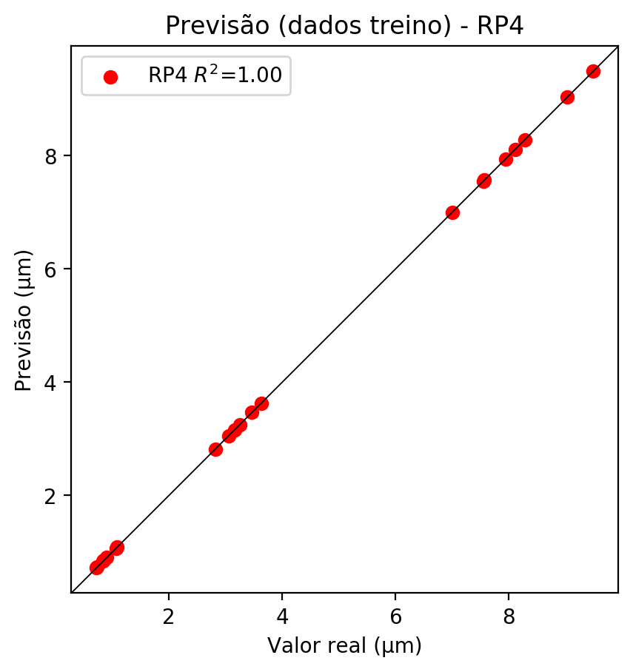

# Geral

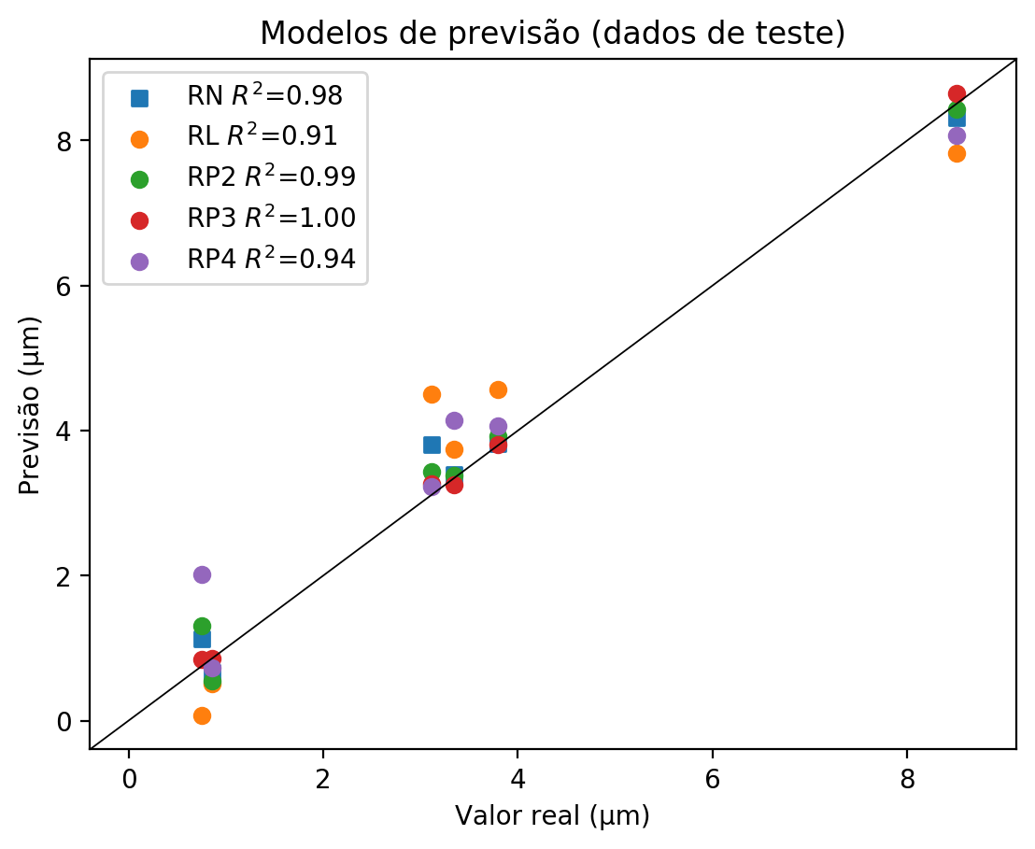

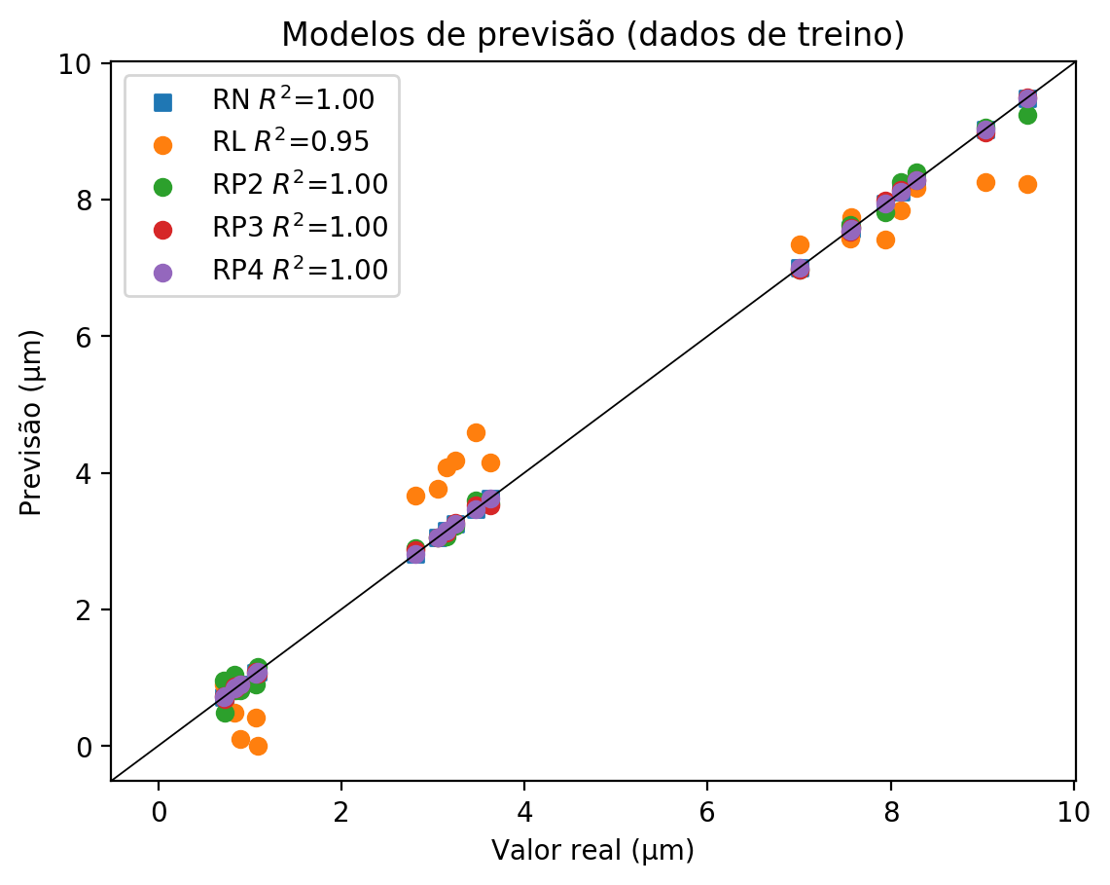

**Dados de teste**

|  |  |  |  |  |  |  |  |  |  |  |
| --- | --- | --- | --- | --- | --- | --- | --- | --- | --- | --- |
| Valor real | RN Previsto | RN Erro (%) | RL Previsto | RL Erro (%) | RP2 Previsto | RP2 Erro (%) | RP3 Previsto | RP3 Erro (%) | RP4 Previsto | RP4 Erro (%) |
| 0.76 | 1.13 | 49.67 | 0.07 | 90.73 | 1.31 | 73.51 | 0.84 | 11.26 | 2.02 | 167.55 |
| 8.5 | 8.31 | 2.27 | 7.82 | 8.03 | 8.43 | 0.86 | 8.65 | 1.73 | 8.07 | 5.09 |
| 3.34 | 3.39 | 1.47 | 3.74 | 11.94 | 3.38 | 1.17 | 3.25 | 2.72 | 4.14 | 23.91 |
| 3.79 | 3.82 | 0.69 | 4.56 | 20.19 | 3.92 | 3.32 | 3.81 | 0.42 | 4.06 | 7.01 |
| 0.86 | 0.66 | 23.08 | 0.51 | 40.56 | 0.55 | 35.9 | 0.86 | 0.23 | 0.73 | 14.92 |
| 3.11 | 3.81 | 22.47 | 4.5 | 44.65 | 3.43 | 10.25 | 3.27 | 5.11 | 3.23 | 3.83 |

**Dados de treino**

|  |  |  |  |  |  |  |  |  |  |  |
| --- | --- | --- | --- | --- | --- | --- | --- | --- | --- | --- |
| Valor real | RN Previsto | RN Erro (%) | RL Previsto | RL Erro (%) | RP2 Previsto | RP2 Erro (%) | RP3 Previsto | RP3 Erro (%) | RP4 Previsto | RP4 Erro (%) |
| 8.28 | 8.28 | 0.01 | 8.17 | 1.32 | 8.4 | 1.46 | 8.28 | 0.01 | 8.28 | 0.01 |
| 3.25 | 3.25 | 0.09 | 4.18 | 28.73 | 3.22 | 0.83 | 3.26 | 0.4 | 3.25 | 0.09 |
| 7.56 | 7.56 | 0.07 | 7.43 | 1.65 | 7.63 | 0.99 | 7.53 | 0.33 | 7.55 | 0.07 |
| 7.57 | 7.57 | 0.03 | 7.75 | 2.4 | 7.6 | 0.42 | 7.59 | 0.29 | 7.57 | 0.03 |
| 3.63 | 3.63 | 0.0 | 4.15 | 14.33 | 3.55 | 2.2 | 3.53 | 2.75 | 3.63 | 0.0 |
| 0.73 | 0.73 | 0.41 | 0.92 | 26.55 | 0.48 | 33.98 | 0.69 | 5.09 | 0.73 | 0.41 |
| 3.06 | 3.05 | 0.16 | 3.76 | 23.08 | 3.05 | 0.16 | 3.05 | 0.16 | 3.05 | 0.16 |
| 9.49 | 9.49 | 0.01 | 8.23 | 13.27 | 9.24 | 2.62 | 9.5 | 0.12 | 9.49 | 0.01 |
| 9.03 | 9.03 | 0.01 | 8.26 | 8.54 | 9.06 | 0.32 | 8.99 | 0.45 | 9.03 | 0.01 |
| 1.09 | 1.09 | 0.28 | 0.0 | 100.0 | 1.16 | 6.72 | 1.05 | 3.4 | 1.09 | 0.28 |
| 0.9 | 0.9 | 0.0 | 0.1 | 88.89 | 0.82 | 8.89 | 0.9 | 0.0 | 0.9 | 0.0 |
| 0.85 | 0.85 | 0.24 | 0.83 | 2.12 | 0.82 | 3.3 | 0.84 | 0.94 | 0.85 | 0.24 |
| 7.0 | 7.0 | 0.06 | 7.34 | 4.8 | 6.98 | 0.34 | 6.97 | 0.49 | 7.0 | 0.06 |
| 2.81 | 2.81 | 0.11 | 3.67 | 30.47 | 2.89 | 2.74 | 2.87 | 2.03 | 2.81 | 0.11 |
| 1.06 | 1.07 | 0.47 | 0.41 | 61.5 | 0.9 | 15.49 | 1.09 | 2.35 | 1.06 | 0.47 |
| 8.12 | 8.11 | 0.06 | 7.85 | 3.27 | 8.25 | 1.66 | 8.15 | 0.43 | 8.11 | 0.06 |
| 0.84 | 0.84 | 0.24 | 0.48 | 42.72 | 1.04 | 24.11 | 0.87 | 3.82 | 0.84 | 0.24 |
| 0.71 | 0.72 | 0.7 | 0.9 | 25.87 | 0.96 | 34.27 | 0.73 | 2.1 | 0.72 | 0.7 |
| 7.94 | 7.94 | 0.04 | 7.41 | 6.71 | 7.82 | 1.55 | 7.98 | 0.47 | 7.94 | 0.04 |
| 3.47 | 3.47 | 0.12 | 4.59 | 32.43 | 3.59 | 3.58 | 3.52 | 1.56 | 3.47 | 0.12 |
| 3.15 | 3.15 | 0.13 | 4.08 | 29.36 | 3.06 | 2.98 | 3.13 | 0.76 | 3.15 | 0.13 |